**Early detection of esophageal cancer: Evaluating AI algorithms with multi- institutional narrowband and white-light imaging data**

Baik et al., PLOS ONE, 2025  
D­­OI: 10.1371/journal.pone.0321092

# INTRODUCTION

According to data, esophageal cancer is one of the most common cancers in the world [1], and what makes it worse is the fact that patients tend to be diagnosed way too late in the disease [2], resulting in quite a poor survival rate. With all that said, if the cancer were to be found early in its stages, it’s quite curable [3]. Unfortunately, doctors have been mainly using white-light imaging (WLI) during the endoscopy procedure to diagnose a patient, and that doesn’t yield the best results as it’s quite cumbersome and ineffective to do [4]. Another useful technique is to identify the structure from the surface of the esophagus using narrowband imaging (NBI) [5]. NBI works much better for helping diagnose and detect early signs of esophageal cancer [6].

Due to the cancer’s complexity and the challenge it is to accurately detect [7], the procedure barely takes place in a person’s life and is often overlooked, resulting in a shortage of high-definition (HD) scans [8]. With the advancements of technology and the effect of artificial intelligence (AI) on medical practices [9], there is hope that using this tool might ease and optimize the early detection of such cancers and be of aid to lesser experienced doctors [10].

Using deep learning (DL), specifically its Convolutional Neural Networks’ (CNNs) variants, has been utilized for detecting signs from images [11]. Even though there are many CNN-based studies, data for esophageal cancer is still limited compared to others, which has led to poor performance on new inputs [12]. Here, Baik et al. are building a new AI model that helps with recognizing early signs of esophageal cancer by checking information on already collected datasets that contain both WLI and NBI formats.

# Materials and methods

Dataset came from a collection of 2,674 images from 619 patients who had done WLI procedur between 2016 and 2020, plus 480 images from 121 patients with NBI. Every image from one patient was put into either the training, validation, or test set, making sure there is zero overlap and data leakage. Since WLI and NBI sampleshad multiple dimensions, everything was resized to 640x640.

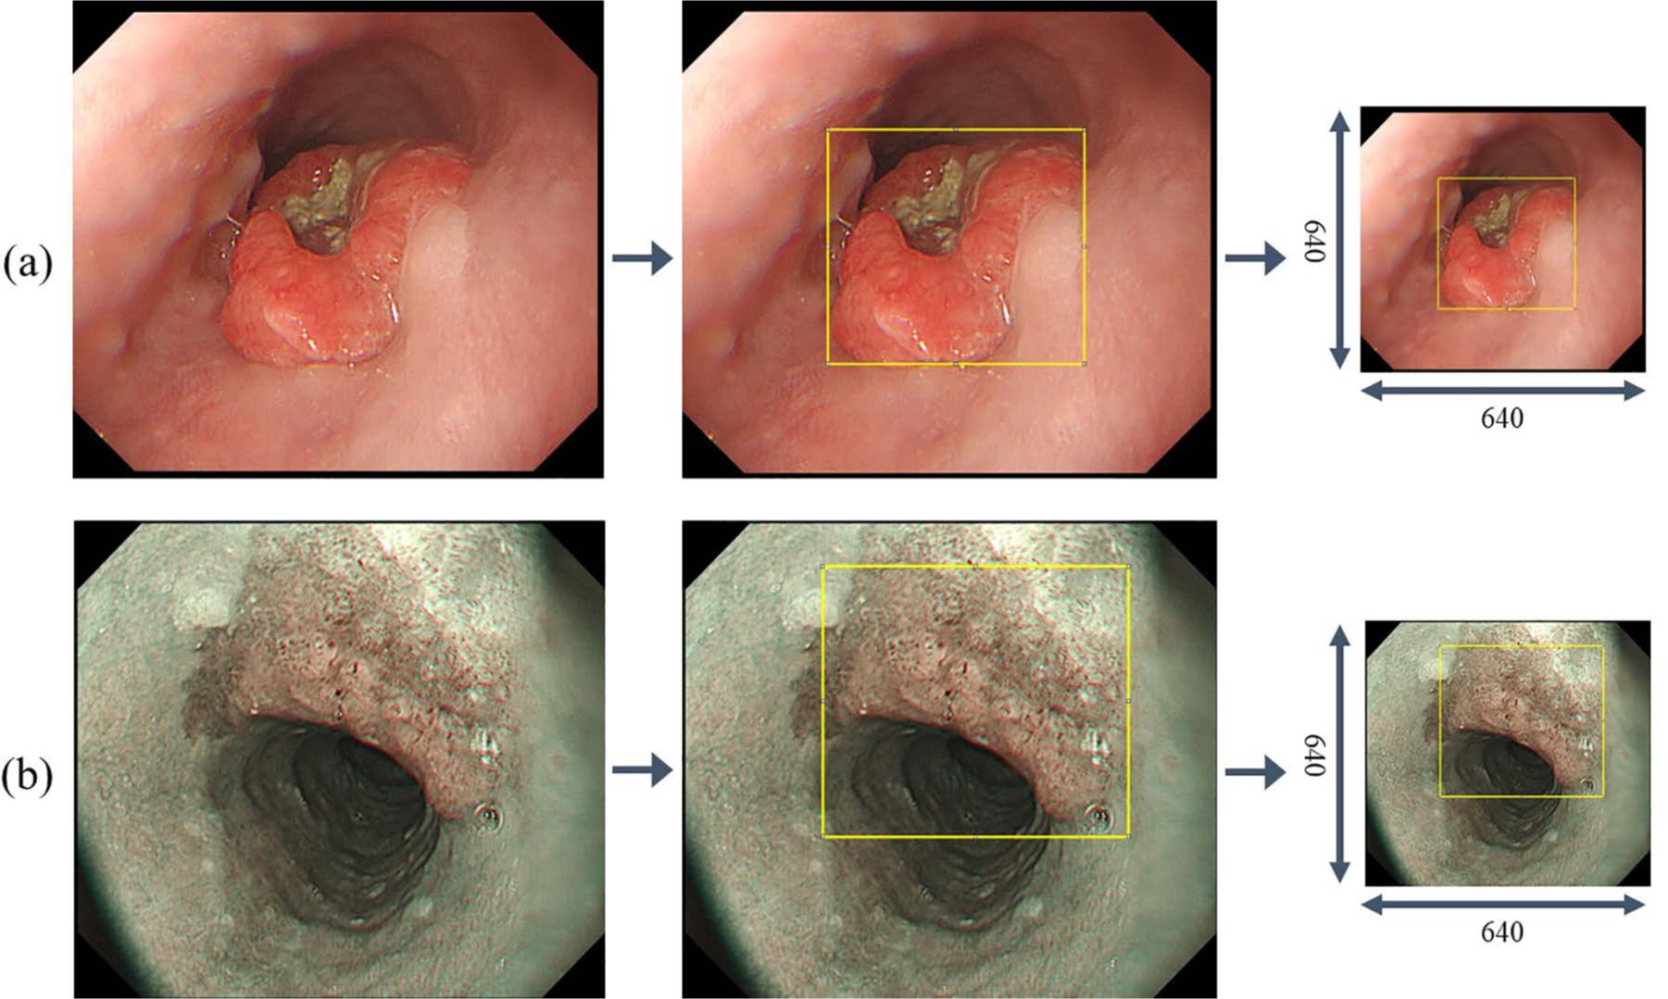

Fig 1. Labeling data for regions of interest, (a) WLI, (b) NBI

A gastroenterologist with 10+ years of experience was present during the model training to label the tumors. To detect tumors in the endoscopy images, authors used the YOLOv5 model, which is known as a single stage object detection model (ODM). After training, model’s performance and precision, and false positives per image (FPPI) were checked.

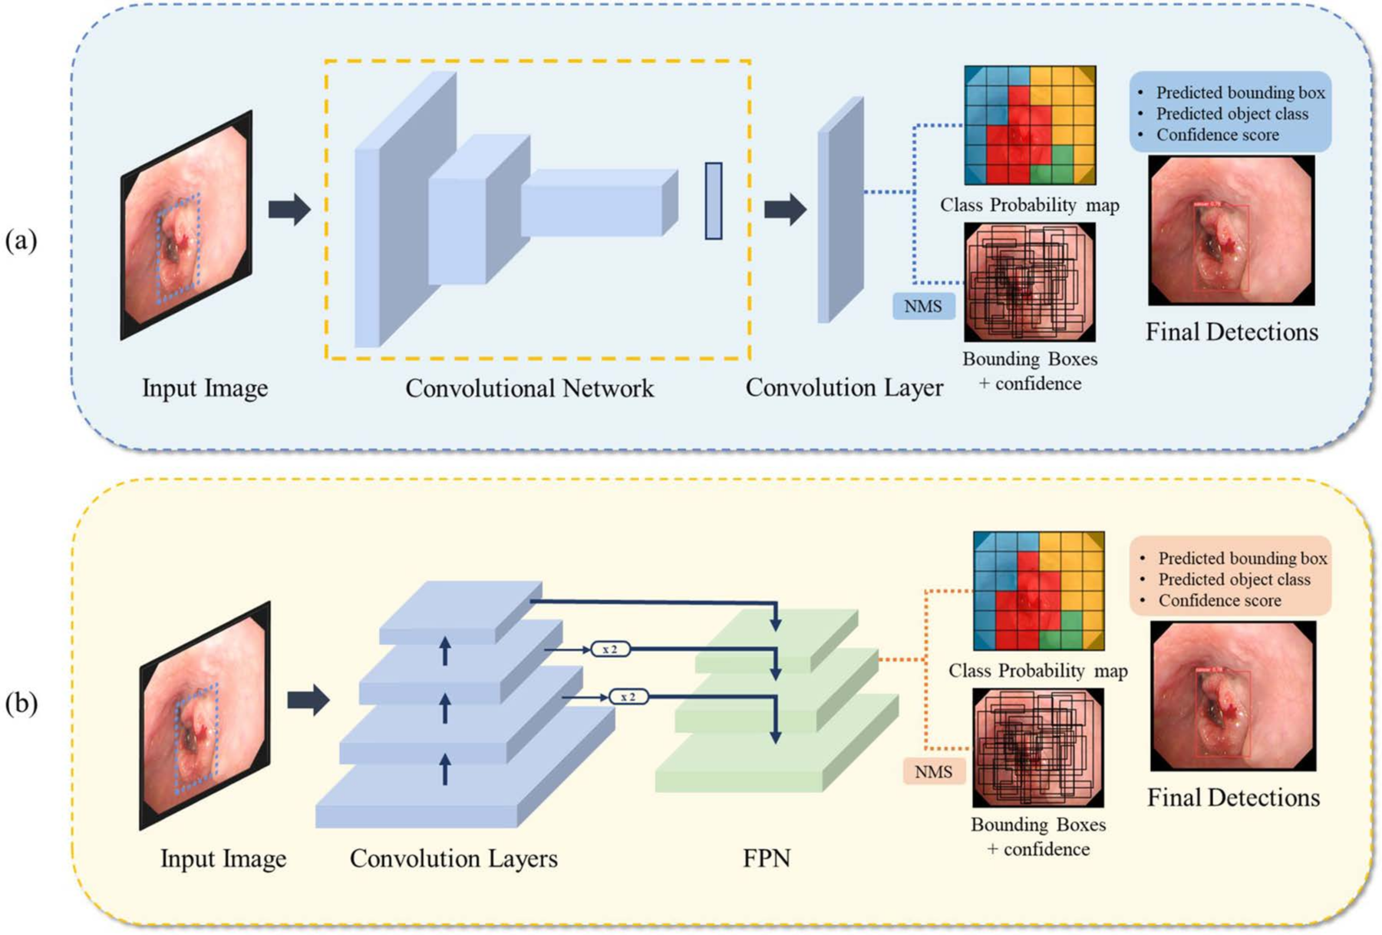

Fig 2. Tumor detection in esophageal Endoscopy, (a) YOLOv5, (b) RetinaNet.

# Results and discussion

Finally, models were tested on two types of data: normal images and images with esophageal lesions. Basically, lesion were marked as true and vice versa. For the WLI dataset, the YOLOv5 model hit a precision of 93.7%, and for NBI it scored 86.5% in precision. So, based on the results, this model could definitely help spot tumors by analyzing the images. While prior studies mainly focused on polyp detection, this one goes a step further by focusing on early-stage esophageal cancer [11-19]. That said, a few limitations are still present, such as the poor results against unseen and rare shapes the cancer might take upon.

Going forward, collecting more data, re-training, and tweaking the hyperparameters are some of the recommendations from the authors [20]. Also, optimizing the speed and size of the model could help it run in real-time, which would be useful in medical clinics, resulting in helping new and unexperienced doctors make quick and accurate decisions on the fly.

# References

1. Pohl H, Sirovich B, Welch HG. Esophageal adenocarcinoma incidence: Are we reaching the peak? Cancer Epidemiol Biomarkers Prev. 2010;19(6):1468–70. https://doi.org/10.1158/1055-9965.EPI-10- 0012 PMID: 20501776

2. Hur C, Miller M, Kong CY, Dowling EC, Nattinger KJ, Dunn M, et al. Trends in esophageal adenocarci- noma incidence and mortality. Cancer. 2013;119(6):1149–58. https://doi.org/10.1002/cncr.27834 PMID:23303625

3. Behrens A, et al. Barrett’s adenocarcinoma of the esophagus: Better outcomes through new methods of diagnosis and treatment. Dtsch Ärztebl Int. 2011 108(2011):313. <https://doi>. org/10.3238%2Farztebl.2011.0313

4. Nagami Y, Tominaga K, Machida H, Nakatani M, Kameda N, Sugimori S, et al. Usefulness of non-magnifying narrow-band imaging in screening of early esophageal squamous cell carcinoma: A prospective comparative study using propensity score matching. Am J Gastroenterol. 2014;109(6):845–54. https://doi.org/10.1038/ajg.2014.94 PMID: 24751580

5. Lee YC, Wang CP, Chen CC, Chiu HM, Ko JY, Lou PJ, et al. Transnasal endoscopy with narrow-band imaging and Lugol staining to screen patients with head and neck cancer whose condition limits oral intubation with standard endoscope (with video). Gastrointest Endosc. 2009;69(3 Pt 1):408–17. https://doi.org/10.1016/j.gie.2008.05.033 PMID: 19019362

6. Kuraoka K, Hoshino E, Tsuchida T, Fujisaki J, Takahashi H, Fujita R. Early esophageal cancer can be detected by screening endoscopy assisted with narrow-band imaging (NBI). Hepatogastroenterology. 2009;56(89):63–6. PMID: 19453030

7. Li H, Liu D, Zeng Y, Liu S, Gan T, Rao N, et al. Single-image-based deep learning for segmenta- tion of early esophageal cancer lesions. IEEE Trans Image Process. 2024;33:2676–88. https://doi. org/10.1109/TIP.2024.3379902 PMID: 38530733

8. Pennathur A, Gibson MK, Jobe BA, Luketich JD. Oesophageal carcinoma. Lancet.

2013;381(9864):400–12. <https://doi.org/10.1016/S0140-6736(12)60643-6> PMID: 23374478

9. Kudo SE, Misawa M, Mori Y, Hotta K, Ohtsuka K, Ikematsu H, et al. Artificial intelligence-assisted system improves endoscopic identification of colorectal neoplasms. Clin Gastroenterol Hepatol. 2020;18(8):1874–1881.e2. https://doi.org/10.1016/j.cgh.2019.09.009 PMID: 31525512

10. Walter FM, Rubin G, Bankhead C, Morris HC, Hall N, Mills K, et al. Symptoms and other factors associated with time to diagnosis and stage of lung cancer: A prospective cohort study. Br J Cancer. 2015;112(Suppl 1):S6-13. https://doi.org/10.1038/bjc.2015.30 PMID: 25734397

11. Horie Y, Yoshio T, Aoyama K, Yoshimizu S, Horiuchi Y, Ishiyama A, et al. Diagnostic outcomes of esophageal cancer by artificial intelligence using convolutional neural networks. Gastrointest Endosc. 2019;89(1):25–32. https://doi.org/10.1016/j.gie.2018.07.037 PMID: 30120958

12. Malick A, Soroush A, Abrams JA. Esophageal dysbiosis and esophageal squamous cell carcinoma. Esoph Dis Microbiome. 2023:91–114. https://doi.org/10.1016/b978-0-323-95070-1.00014-x

13. Ikenoyama Y, Hirasawa T, Ishioka M, Namikawa K, Yoshimizu S, Horiuchi Y, et al. Detecting early gastric cancer: Comparison between the diagnostic ability of convolutional neural net- works and endoscopists. Dig Endosc. 2021;33(1):141–50. https://doi.org/10.1111/den.13688 PMID:32282110

14. Ribeiro E, Uhl A, Wimmer G, Häfner W. Exploring deep learning and transfer learning for colonic polyp classification. Comput Math Methods Med. 2016;2016:6584725. <https://doi>. org/10.1155/2016/6584725 PMID: 27847543

15. Ding Z, et al. Gastroenterologist-level identification of small-bowel diseases and normal variants by capsule endoscopy using a deep-learning model. Gastroenterology.157(2019):1044–1054. https://doi. org/10.1053/j.gastro.2019.06.025

16. Wang P, Xiao X, Glissen Brown JR, Berzin TM, Tu M, Xiong F, et al. Development and validation of a deep-learning algorithm for the detection of polyps during colonoscopy. Nat Biomed Eng. 2018;2(10):741–8. https://doi.org/10.1038/s41551-018-0301-3 PMID: 31015647

17. Zhang X, Chen F, Yu T, An J, Huang Z, Liu J, et al. Real-time gastric polyp detection using con- volutional neural networks. PLoS One. 2019;14(3):e0214133.https://doi.org/10.1371/journal. pone.0214133 PMID: 30908513

18. Goda K, Tajiri H, Ikegami M, Yoshida Y, Yoshimura N, Kato M, et al. Magnifying endoscopy with narrow band imaging for predicting the invasion depth of superficial esophageal squamous cell carci- noma. Dis Esophagus. 2009;22(5):453–60. https://doi.org/10.1111/j.1442-2050.2009.00942.x PMID: 19222533

19. Nakagawa K, Ishihara R, Aoyama K, Ohmori M, Nakahira H, Matsuura N, et al. Classification for invasion depth of esophageal squamous cell carcinoma using a deep neural network compared with experienced endoscopists. Gastrointest Endosc. 2019;90(3):407–14. https://doi.org/10.1016/j. gie.2019.04.245 PMID: 31077698

20. Wang CC, Chiu YC, Chen WL, Yang TW, Tsai MC, Tseng MH. A deep learning model for classification of endoscopic gastroesophageal reflux disease. Int J Environ Res Public Health. 2021;18(5):2428. https://doi.org/10.3390/ijerph18052428 PMID: 33801325